Deep learning

Spark with H2o

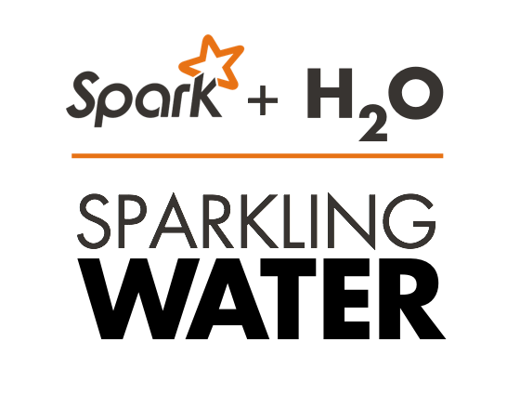

Deepa Maret

TAble of  
Contents

Sparkling Water (Spark+H2O) 1

Problem Statement 1

Description of Data 1

Description of Hardware 3

Description of Technology Used 3

Software Installation 4

Download Data Set 8

Cleaning up the Data Set 10

Data Visualization 13

Deep Learning Using Sparkling Water 19

Preparation of Data 19

Training Deep Learning Models 21

Compare the Performance of Three Models 22

Inspecting Model 3: Confusion Matrix and h2o.scoreHistory() 23

Plotting Performance of Model 3: 23

Deep Learning Grid Search 24

Summary/ Lessons Learned 27

You Tube Links: 27

References: 27

# Sparkling Water (Spark+H2O)

## Problem Statement

This study assesses how well we can predict whether or not an individual has an income greater than $50,000 per year based on individual’s age, sex, education, marital status, job type, nationality, ethnicity etc., using deep learning libraries in ***Sparkling Water (Spark + H2o).***

## Description of Data

Dataset used is the “Adult” dataset hosted on UCI’s Machine Learning Repository (<http://archive.ics.uci.edu/ml/datasets/Adult)>. Data Extraction was done by Barry Becker from the 1994 Census database. It contains 48842 instances, 15 variables. It is a mix of continuous and discrete (train=32561, test=16281). Prediction task is to determine whether a person makes over 50K a year.

**Target Variable:**

**income:** >50K, <=50K.

**Predictor Variables:**

**age:** continuous.

**workclass**: Private, Self-emp-not-inc, Self-emp-inc, Federal-gov, Local-gov, State-gov, Without-pay, Never-worked.   
fnlwgt: continuous.

**education:** Bachelors, Some-college, 11th, HS-grad, Prof-school, Assoc-acdm, Assoc-voc, 9th, 7th-8th, 12th, Masters, 1st-4th, 10th, Doctorate, 5th-6th, Preschool.

**education-num**: continuous.

**marital-status:** Married-civ-spouse, Divorced, Never-married, Separated, Widowed, Married-spouse-absent, Married-AF-spouse.

**occupation:** Tech-support, Craft-repair, Other-service, Sales, Exec-managerial, Prof-specialty, Handlers-cleaners, Machine-op-inspct, Adm-clerical, Farming-fishing, Transport-moving, Priv-house-serv, Protective-serv, Armed-Forces.

**relationship:** Wife, Own-child, Husband, Not-in-family, Other-relative, Unmarried.

**race:** White, Asian-Pac-Islander, Amer-Indian-Eskimo, Other, Black.

**sex:** Female, Male.

**capital-gain:** continuous.

**capital-loss:** continuous.

**hours-per-week:** continuous.

**native-country:** United-States, Cambodia, England, Puerto-Rico, Canada, Germany, Outlying-US(Guam-USVI-etc), India, Japan, Greece, South, China, Cuba, Iran, Honduras, Philippines, Italy, Poland, Jamaica, Vietnam, Mexico, Portugal, Ireland, France, Dominican-Republic, Laos, Ecuador, Taiwan, Haiti, Columbia, Hungary, Guatemala, Nicaragua, Scotland, Thailand, Yugoslavia, El-Salvador, Trinadad&Tobago, Peru, Hong, Holand-Netherlands.

**REFERENCE:** <https://archive.ics.uci.edu/ml/datasets/Adult>

## Description of Hardware

* *MacBook Pro/macOS 10.13.1 (17B1003)*
* *Processor Name: Intel Core i7*
* *Processor Speed: 2.9 GHz*
* *Number of Processors: 1*
* *Total Number of Cores: 4*

## Description of Technology Used

***Apache Spark***is a powerful open source processing engine built around speed, ease of use, and sophisticated analytics. It was originally developed at UC Berkeley in 2009.

***H2O*** is an open source, in-memory, distributed, fast, and scalable machine learning and predictive analytics platform that allows you to build machine learning models on big data and provides easy productionalization of those models in an enterprise environment.

***Sparkling Water*** allows users to combine the fast, scalable machine learning algorithms of ***H2O*** with the capabilities of ***Spark***. With Sparkling Water, users can drive computation from Scala/R/Python and utilize the H2O Flow UI, providing an ideal machine learning platform for application developers. Sparkling Water contains the same features and functionality as H2O but provides a way to use H2O with [Spark](http://spark.apache.org/), a large-scale cluster framework.

The ***rsparkling R package*** is an extension package for [sparklyr](http://spark.rstudio.com) that creates an R front-end for the [Sparkling Water](https://mvnrepository.com/search?q=h2o+sparkling+water) Spark package from [H2O](http://h2o.ai). This provides an interface to H2O's high performance, distributed machine learning algorithms on Spark, using R. This package implements basic functionality (creating an H2OContext, showing the H2O Flow interface, and converting between Spark Data Frames and H2O Frames). The main purpose of this package is to provide a connector between sparklyr and H2O's machine learning algorithms.

## Software Installation

1. Download Sparkling Water and follow instructions from <http://h2o-release.s3.amazonaws.com/sparkling-water/rel-2.2/4/index.html>

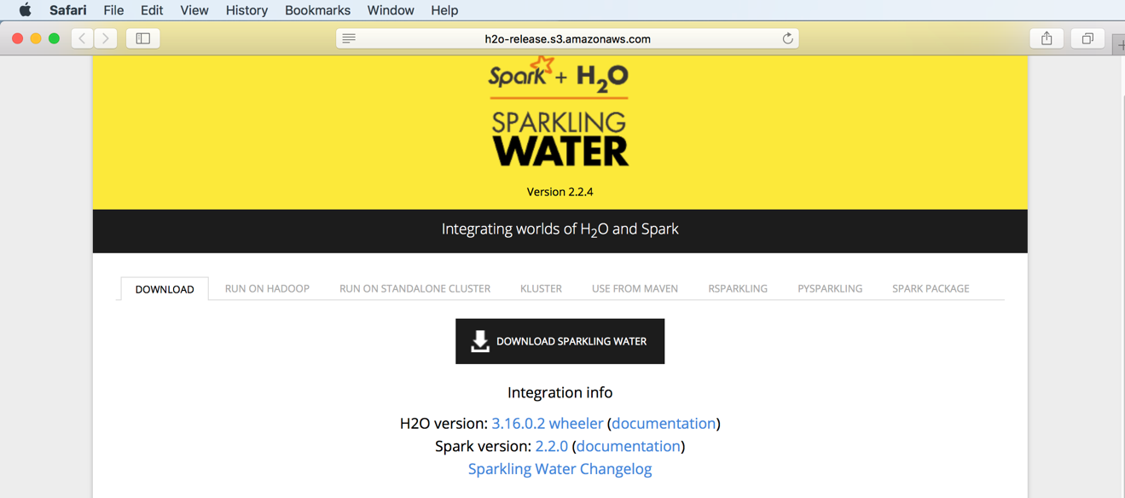

1. RSparkling is a R client for the Sparkling Water applications. To use it: Download and unpack Sparkling Water distribution.
2. Install RSparkling dependency, Sparkly:
3. Install Spark:

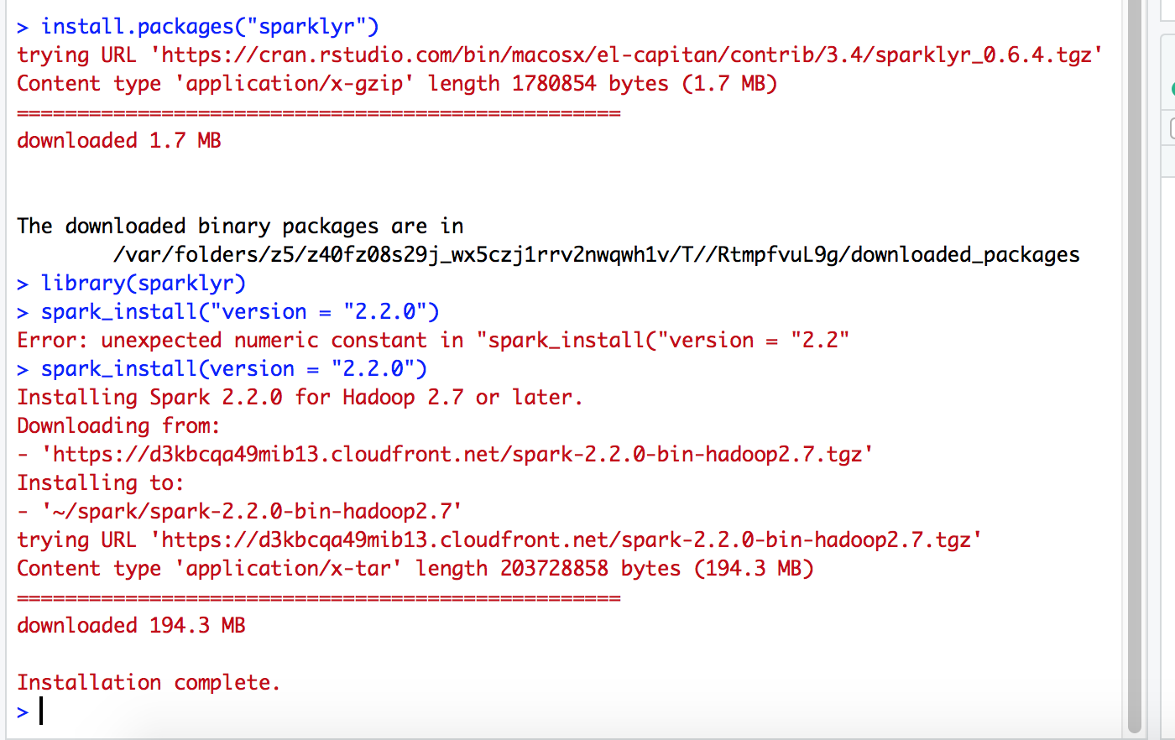

1. Install H2O of correct version:

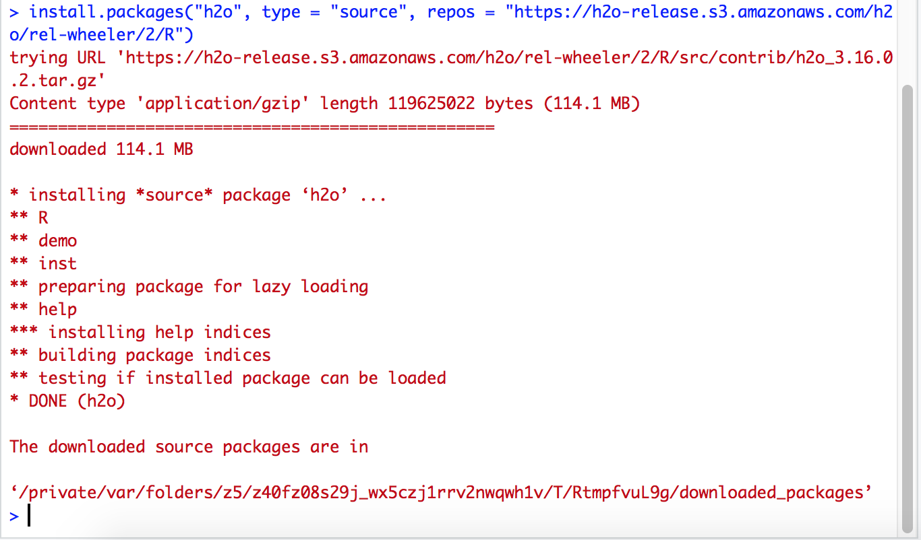

1. Finally, install RSparkling

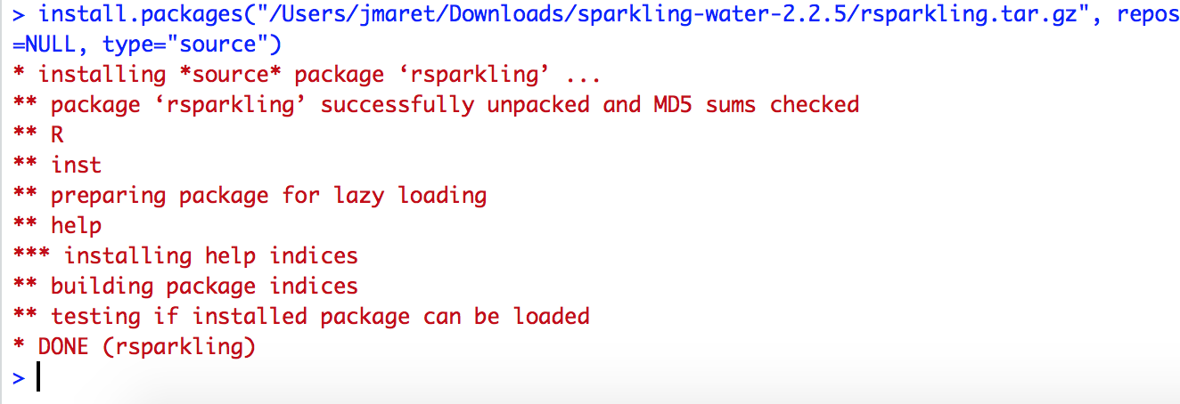

1. Set Sparkling Water version to be used with Rsparkling
2. Connect to Spark
3. h2o_context(sc)

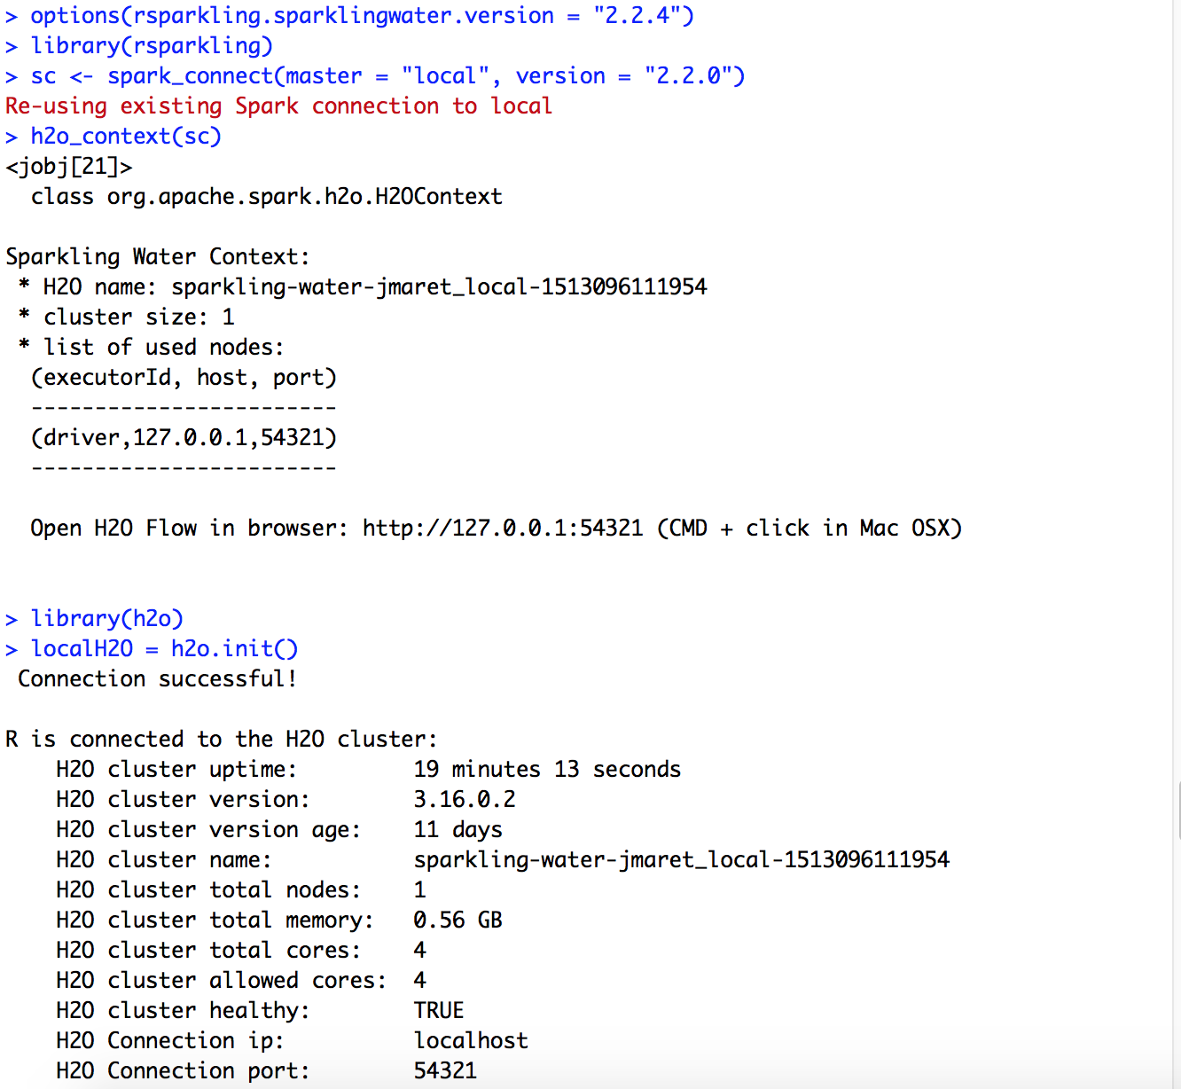

1. Testing demo to check H2o is working properly or not.

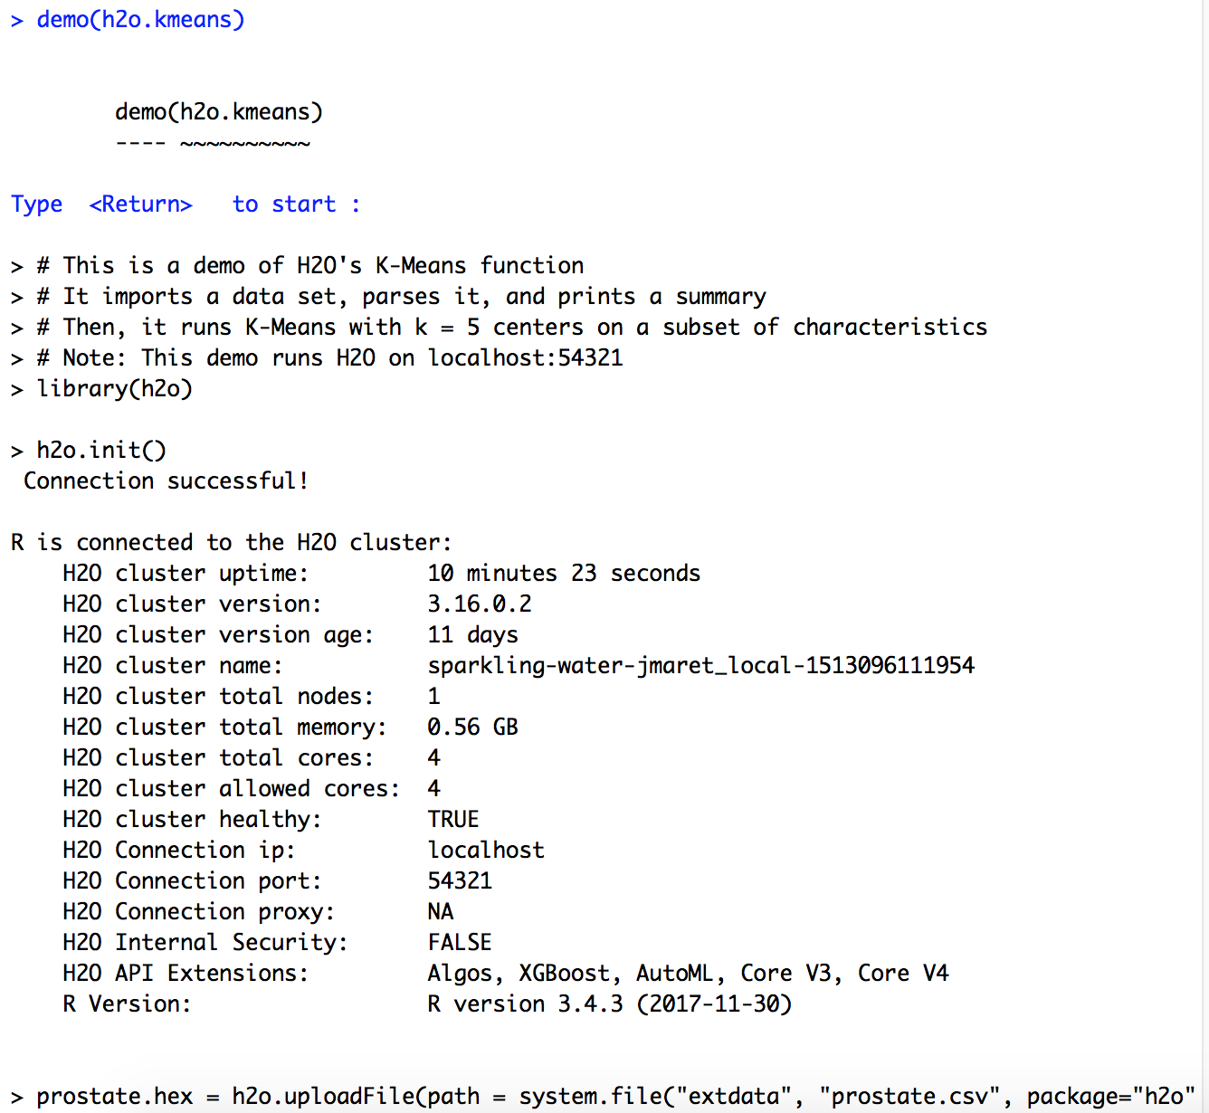

## Download Data Set

Downloaded adult data (adult.data and adult.test) set from <https://archive.ics.uci.edu/ml/datasets/Adult> into the home R directory. Original data has been split up into training and test subsets, but there doesn't seem to be anything particular about that split, so I will combine those two datasets together and split them into training and test as necessary.

*Screenshot of adult data from the UCI Machine Learning Repository*

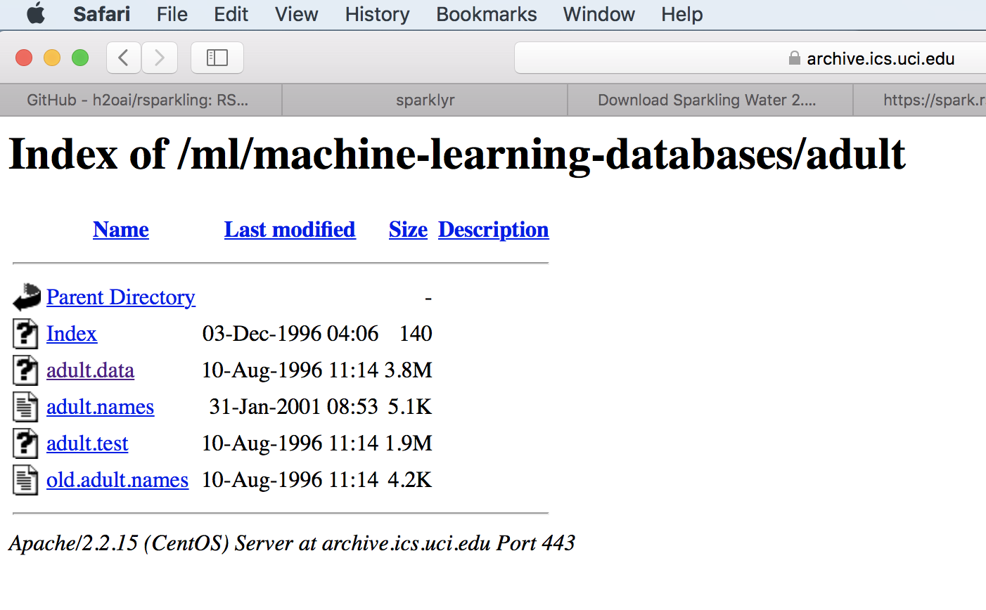

1. Open R studio
2. Load adult.data and naming columns. adult.data contains 32,561 observations and 15 variables.



1. Load adult.test and naming columns. adult.test contains 16,281 observations and 15 variables.



1. Combine adult_data and adult_test to adultDat



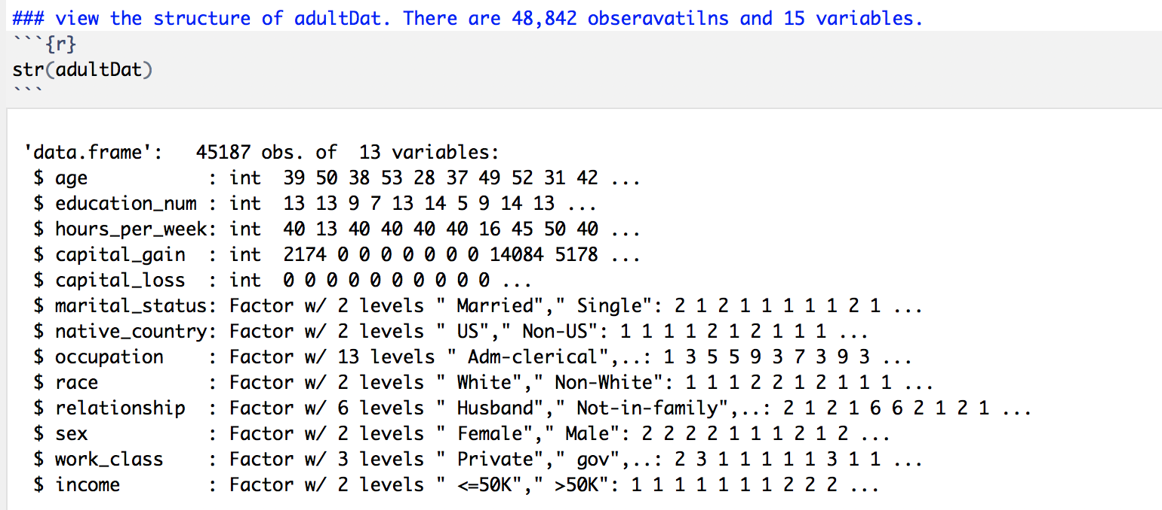

## Cleaning up the Data Set

1. Removing variable "final weight". Now, adultDat contains 48,842 observations and 14 variables.

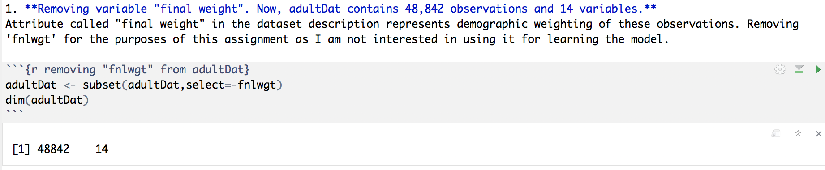

1. Removing education variable since I will use only education.num instead of education. Now, adultDat contains 48,842 observations and 13 variables.

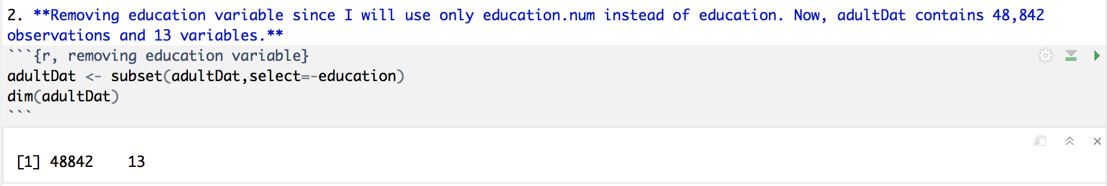

1. Reordering columns; continuous variables followed by categorical variables



1. Cleaning up income variable (Dependent variable). Reducing levels from 4 (<=50K, >50K, <=50K. and >50K.) to 2 (<=50K and >50K)

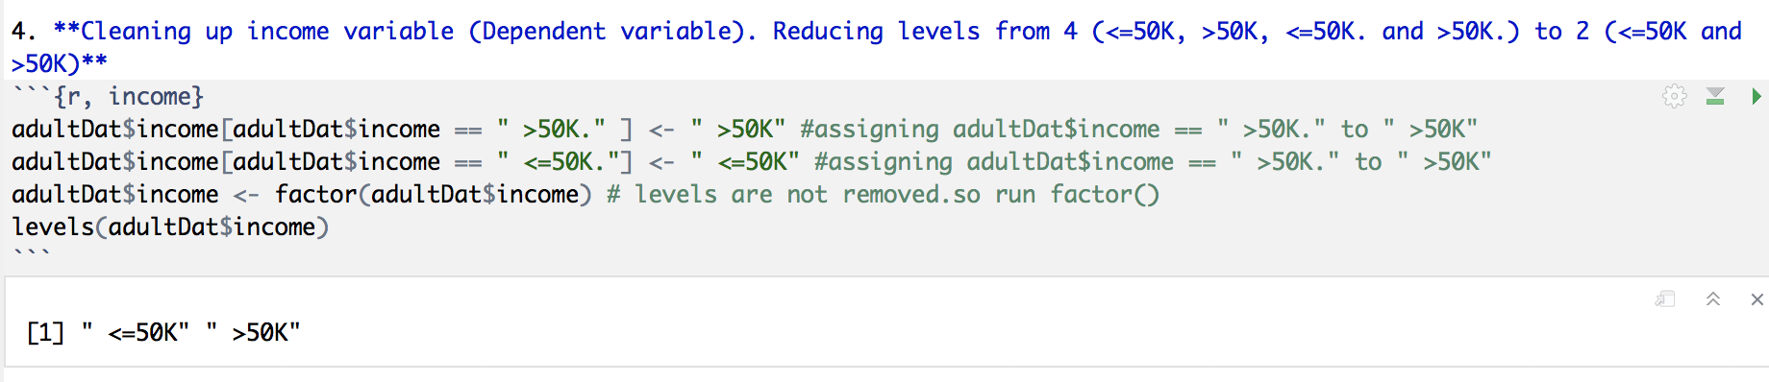

1. Cleaning up marital_status. reduced levels to 2 (Married and Single)

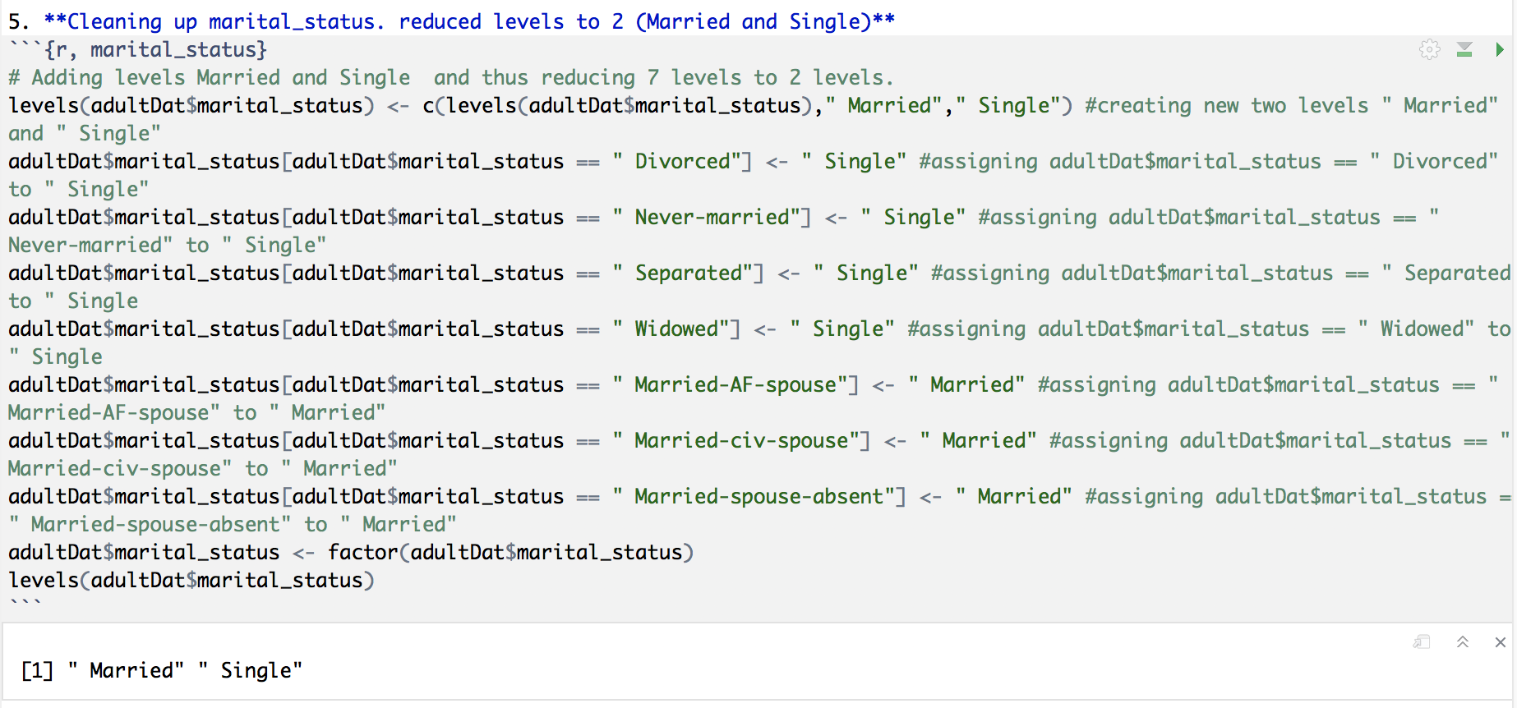

1. Native_country variable. Reduced levels to 2 (US and Non-US)

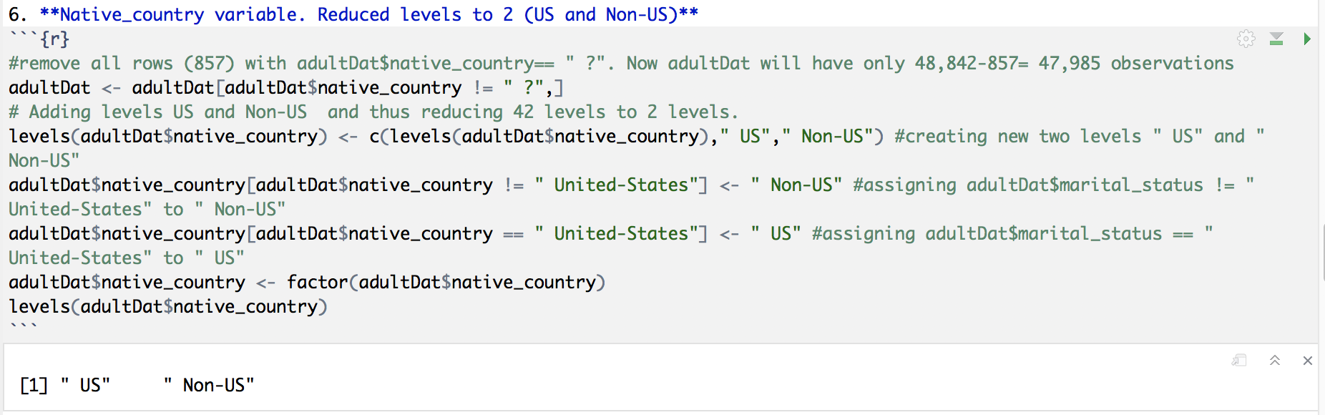

1. Cleaning up occupation variable. reduced levels to 13. Removed rows with " ?" and " Armed-Forces"

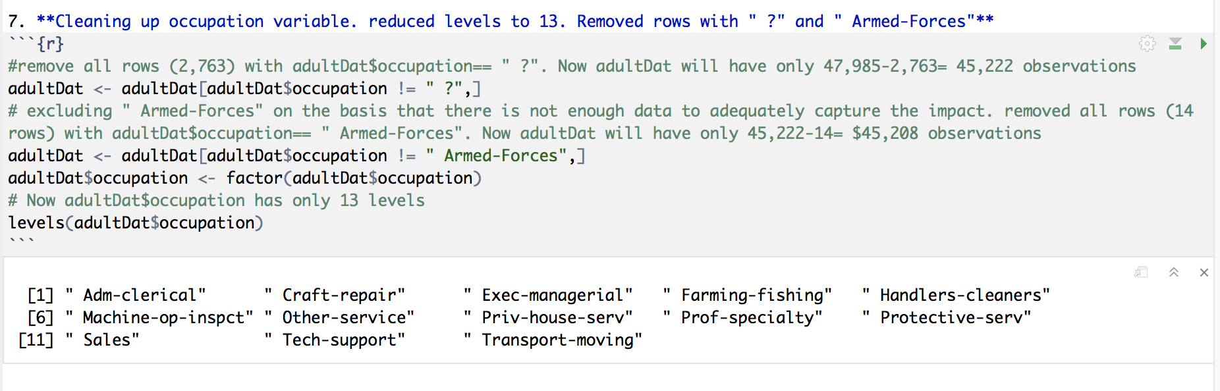

1. Cleaning up race variable. Reduced to 2 levels (White and Non-White)

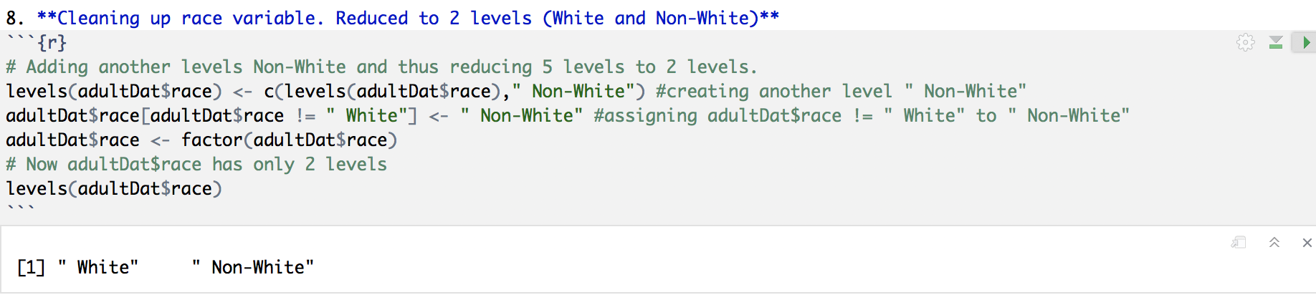

1. Cleaning up work_class variable. reduced levels to 3 (Private, gov, and Self-emp). Removed levels " Without-pay" and " Never-worked"

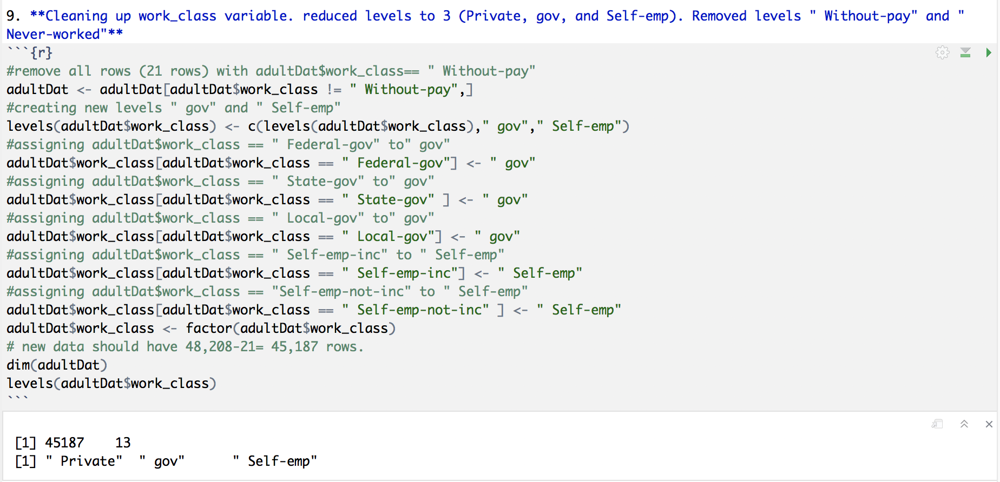

adultDat after cleaning up

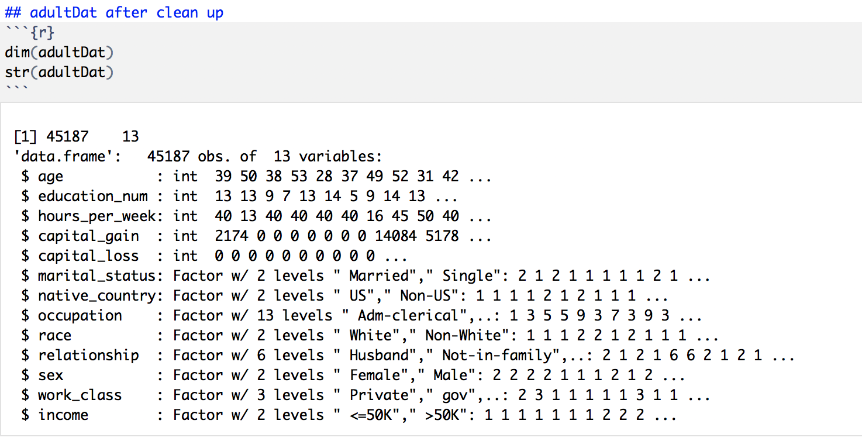

## Data Visualization

1. Plotting quantitative variables against income

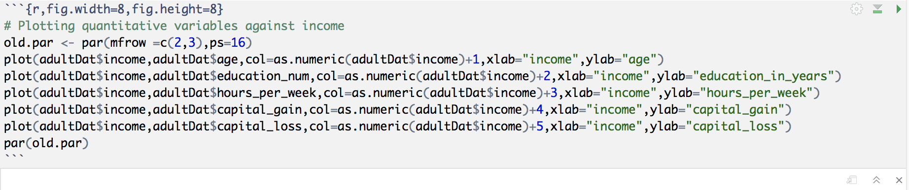

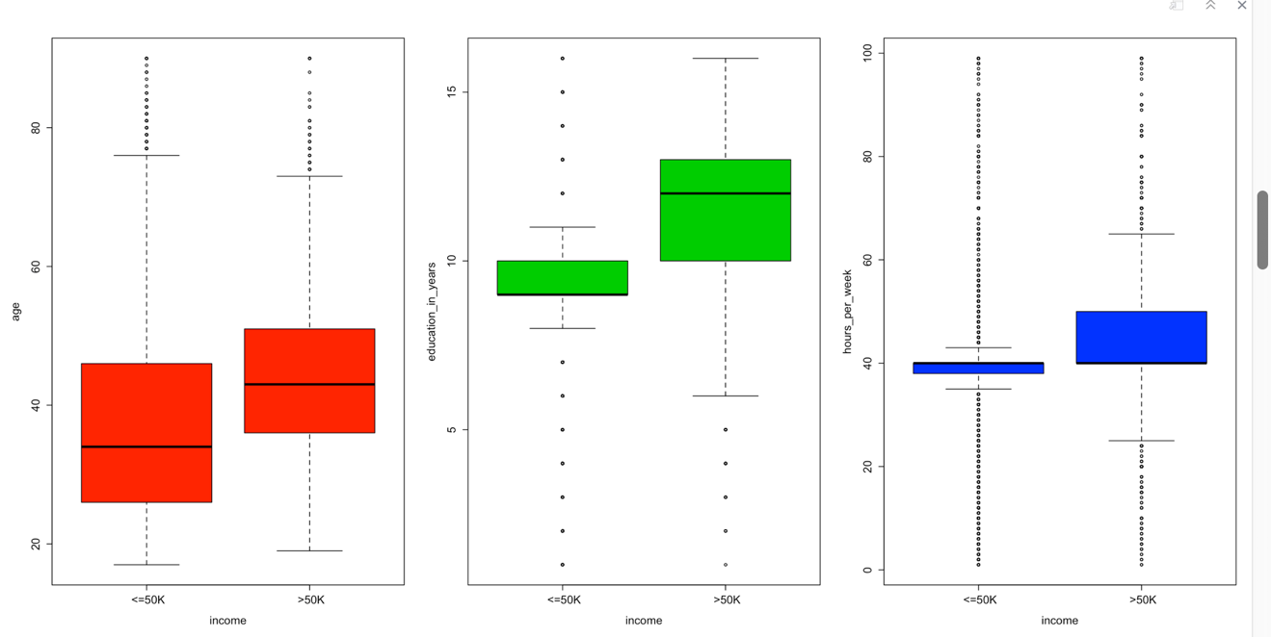

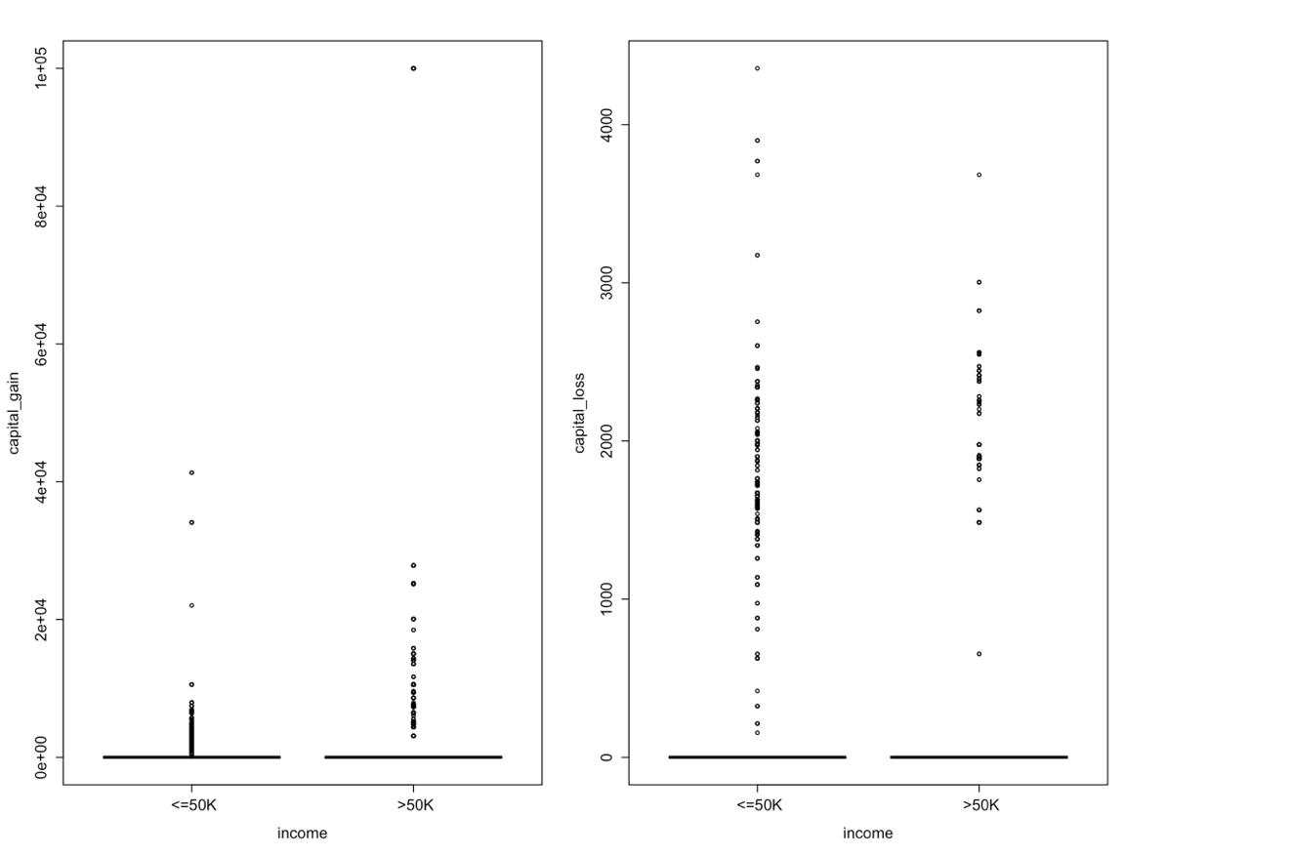

1. Plotting of Categorical Variables

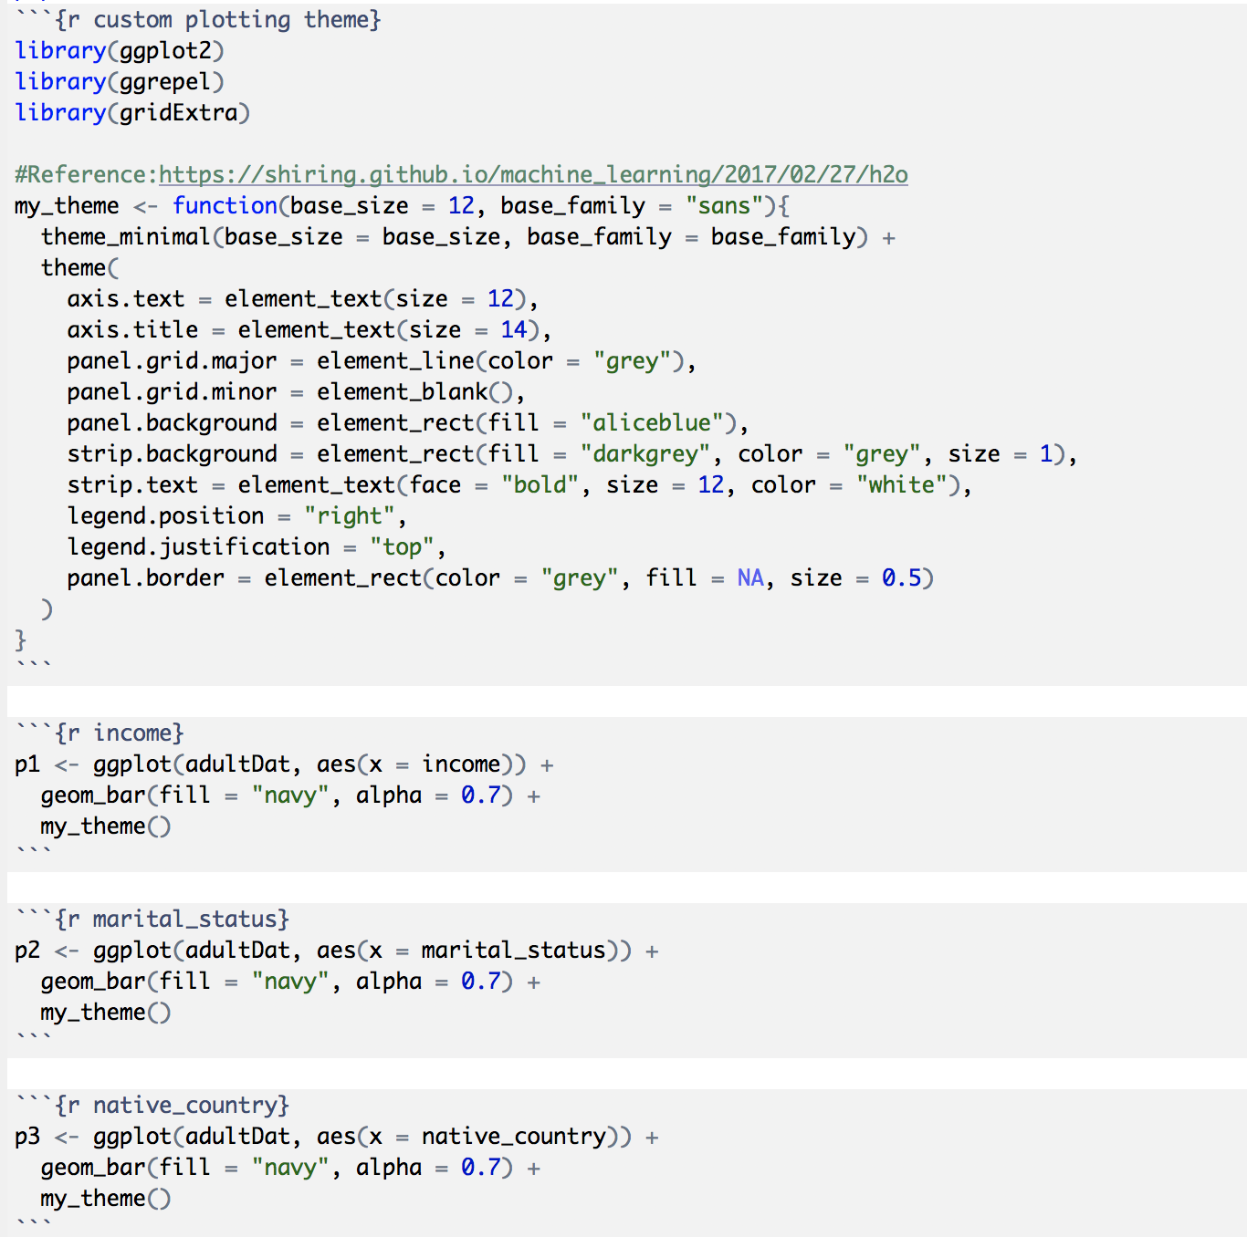

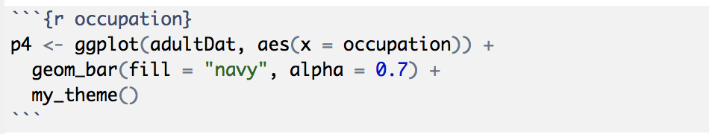

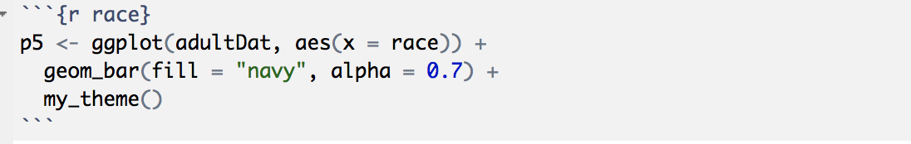

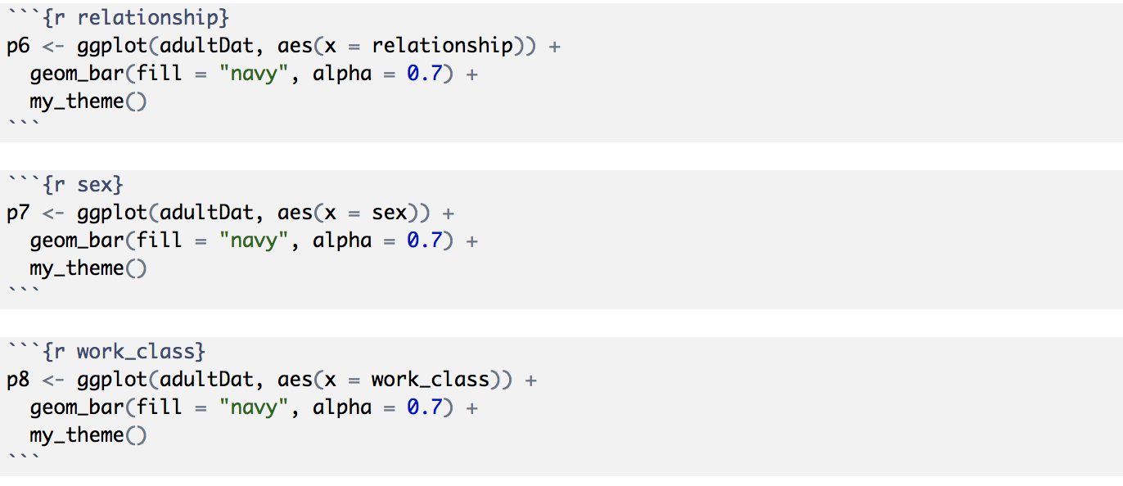

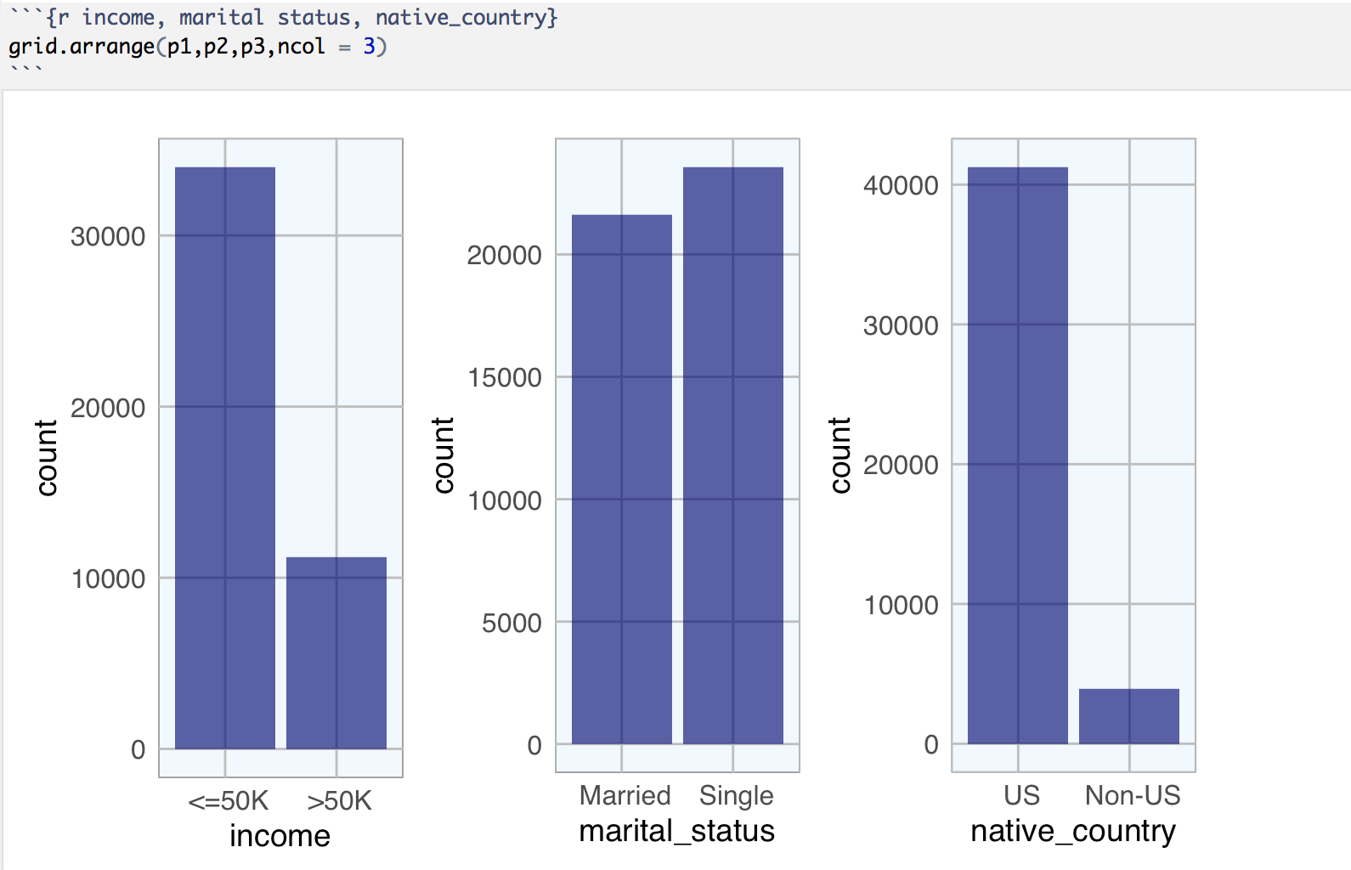

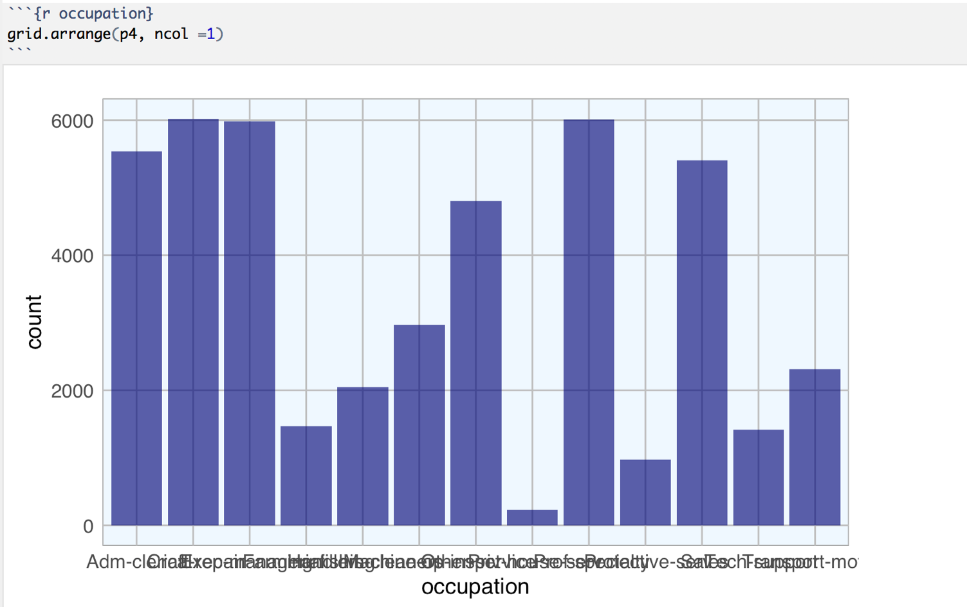

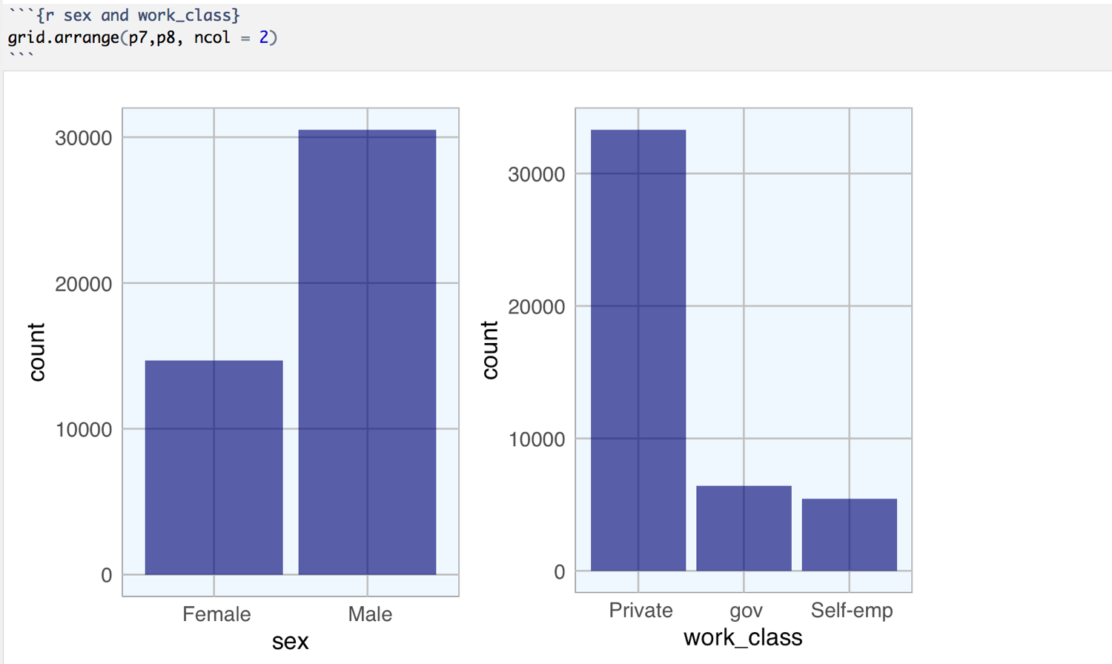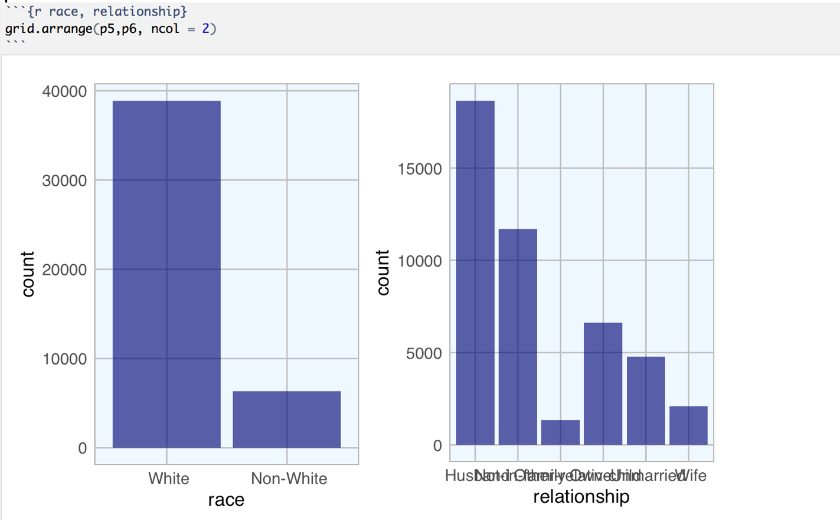

## Deep Learning Using Sparkling Water

### Preparation of Data

1. Loading packages: rsparkling, sparklyr, h2o, dplyr. H20 connection is successful.

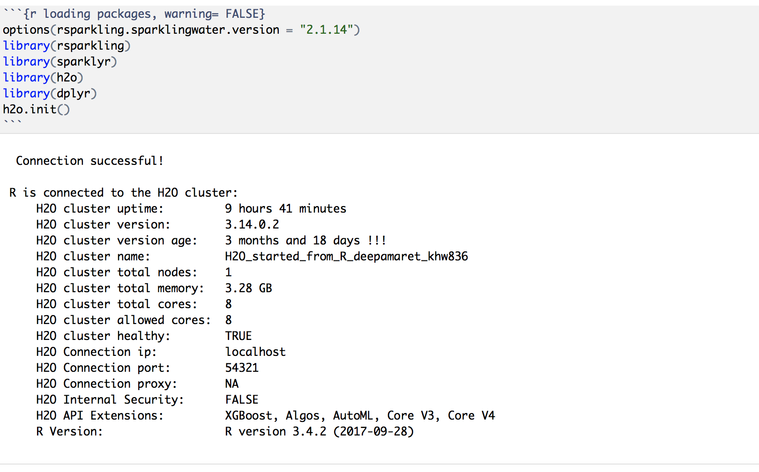

1. Initialized local park connection and copied adultDat data set into spark.

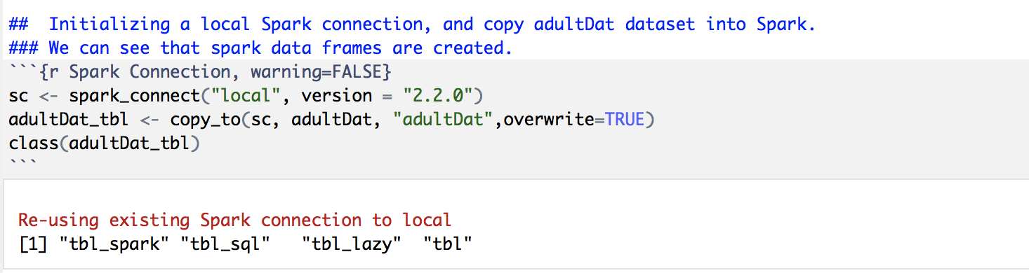

1. Converting Spark Data Frames to h2o Frames. Then h2o R interface can be used to train H2O machine learning/ deep learning algorithms on the data.

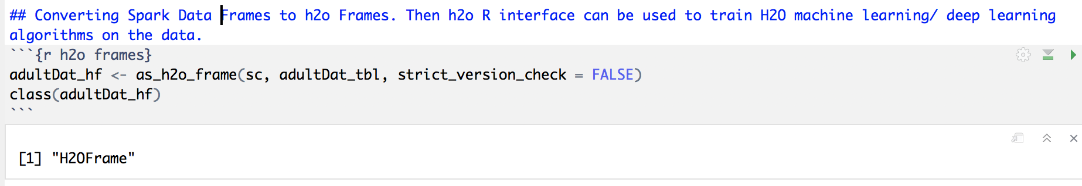

1. View adultDat_hf h2o data frame 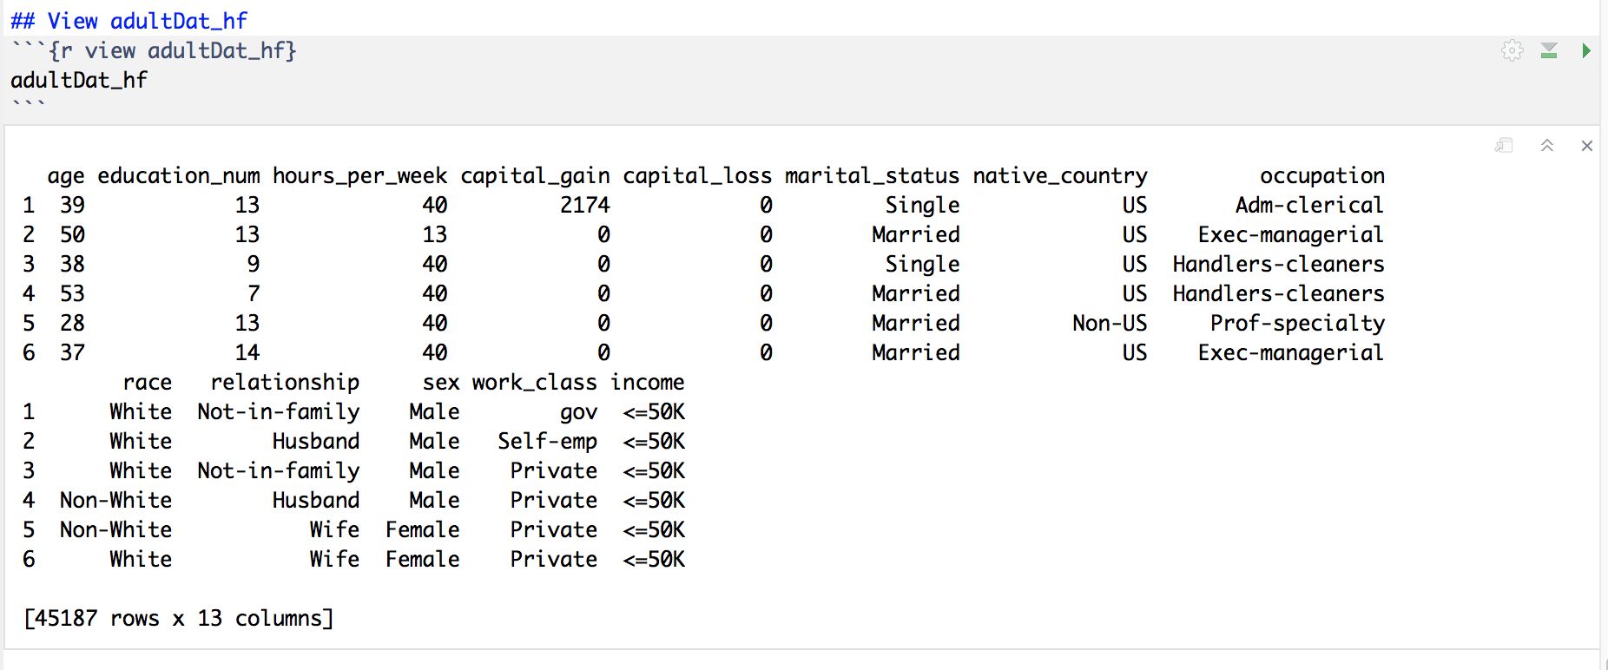
2. Converting categorical variables as factors. Since the response is encoded as integers, we need to tell H2O that the response is in fact a categorical/factor column. Otherwise, it will train a regression model instead of multiclass classification.

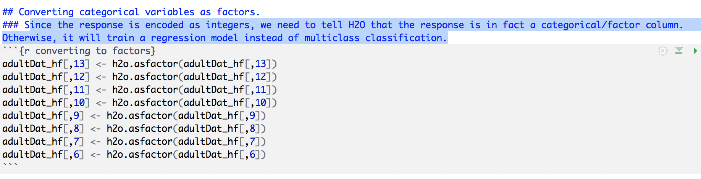

1. Splitting the data into train, test, and valid

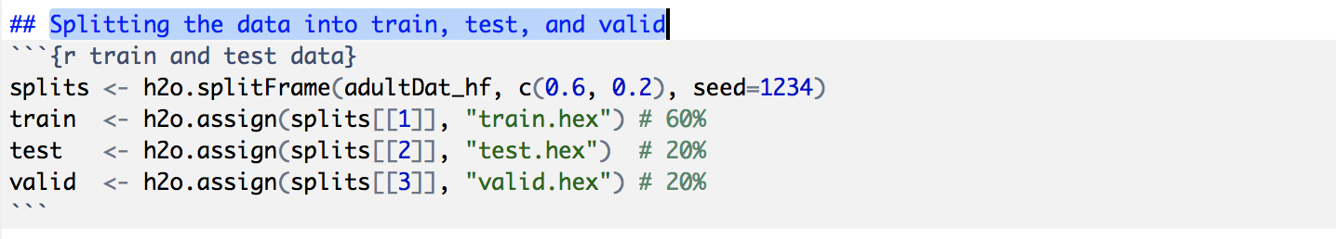

1. Defining response variables and predictor variables

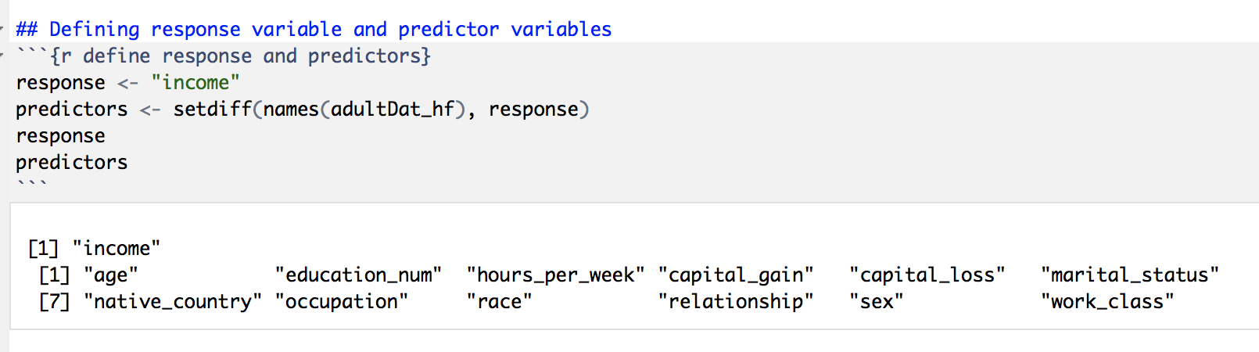

### Training Deep Learning Models

1. **Model1**: First we will train a basic DL (deep learning) model with mostly default parameters

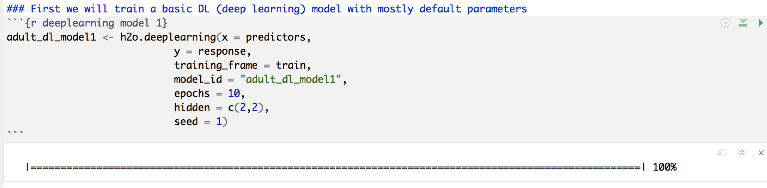

1. **Model 2**: In the second model, we will increase the number of epochs used in the DNN by setting epochs=50 (the default is 10). Increasing the number of epochs in a deep neural net may increase performance of the model, however, we need to be careful not to over fit model to training data. To automatically find the optimal number of epochs, I used H2O’s early stopping functionality. Unlike the rest of the H2O algorithms, H2O’s DL will use early stopping by default. So for comparison I will first turn off early stopping. I will do this in the next example by setting stopping_rounds=0

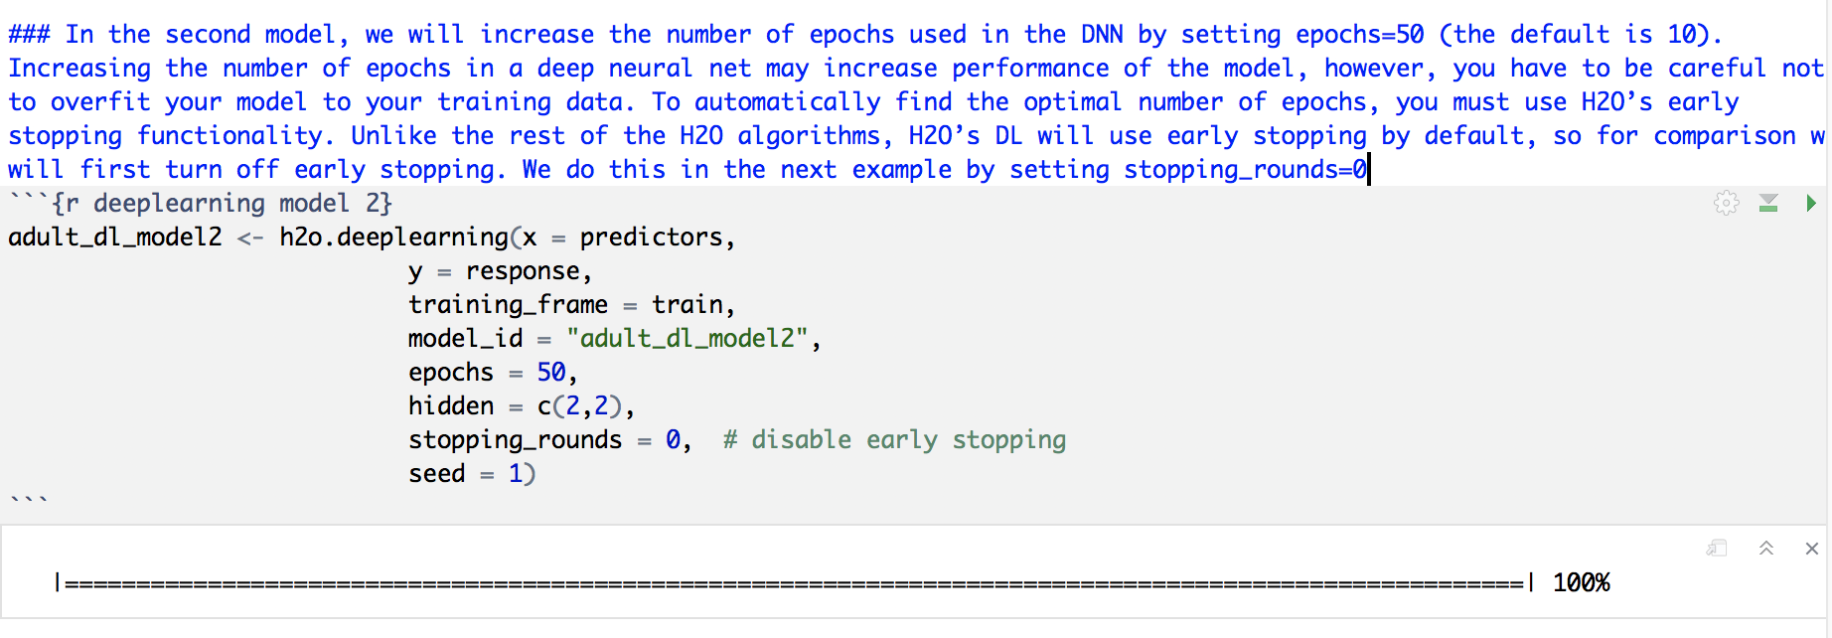

1. **Model 3**: Train deep learning neural net with early stopping: This example will use the same model parameters as adult_dl_model2. However, this time, we will turn on early stopping and specify the stopping criterion. We will use cross-validation (nfolds=3 to determine the optimal number of epochs. Alternatively, we could pass validation set to the validation_frame argument (note: the validation set must be different than the test set).

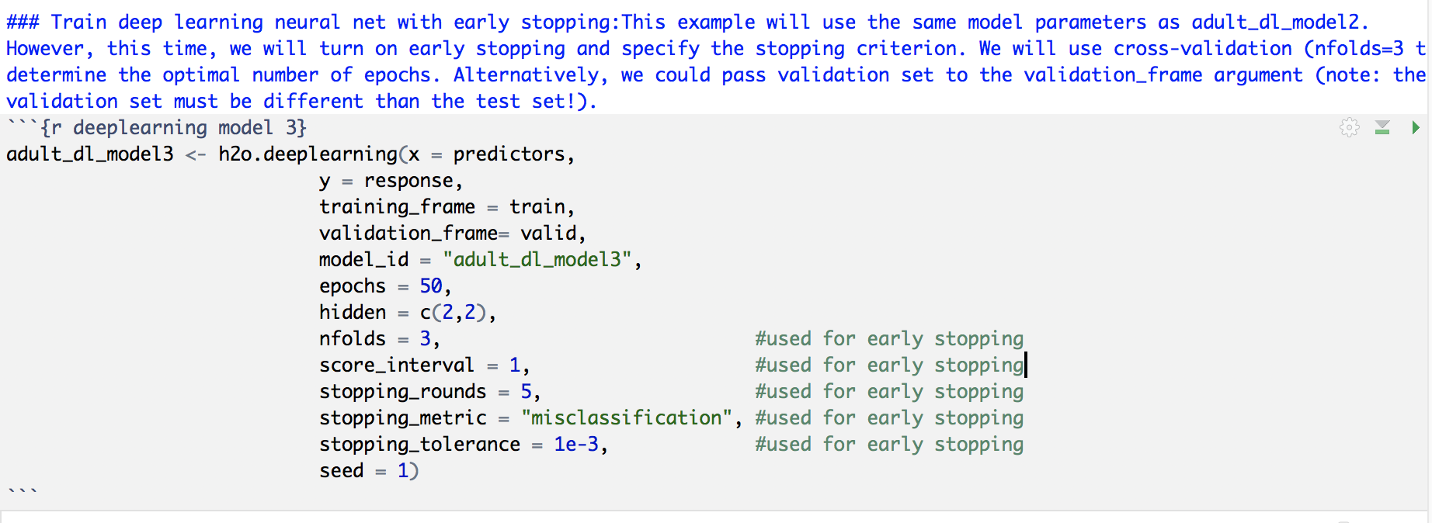

### Compare the Performance of Three Models

Third model comparatively better than the other two with an mse of 0.1044.

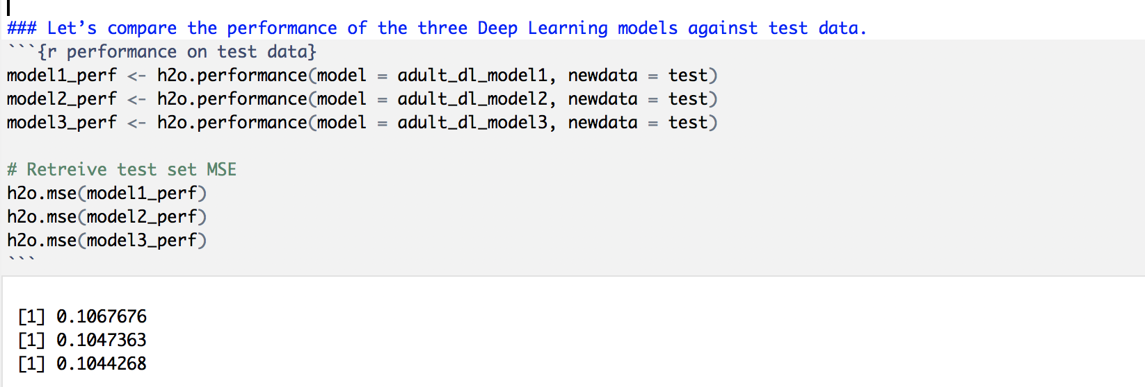

### Inspecting Model 3: Confusion Matrix and h2o.scoreHistory()

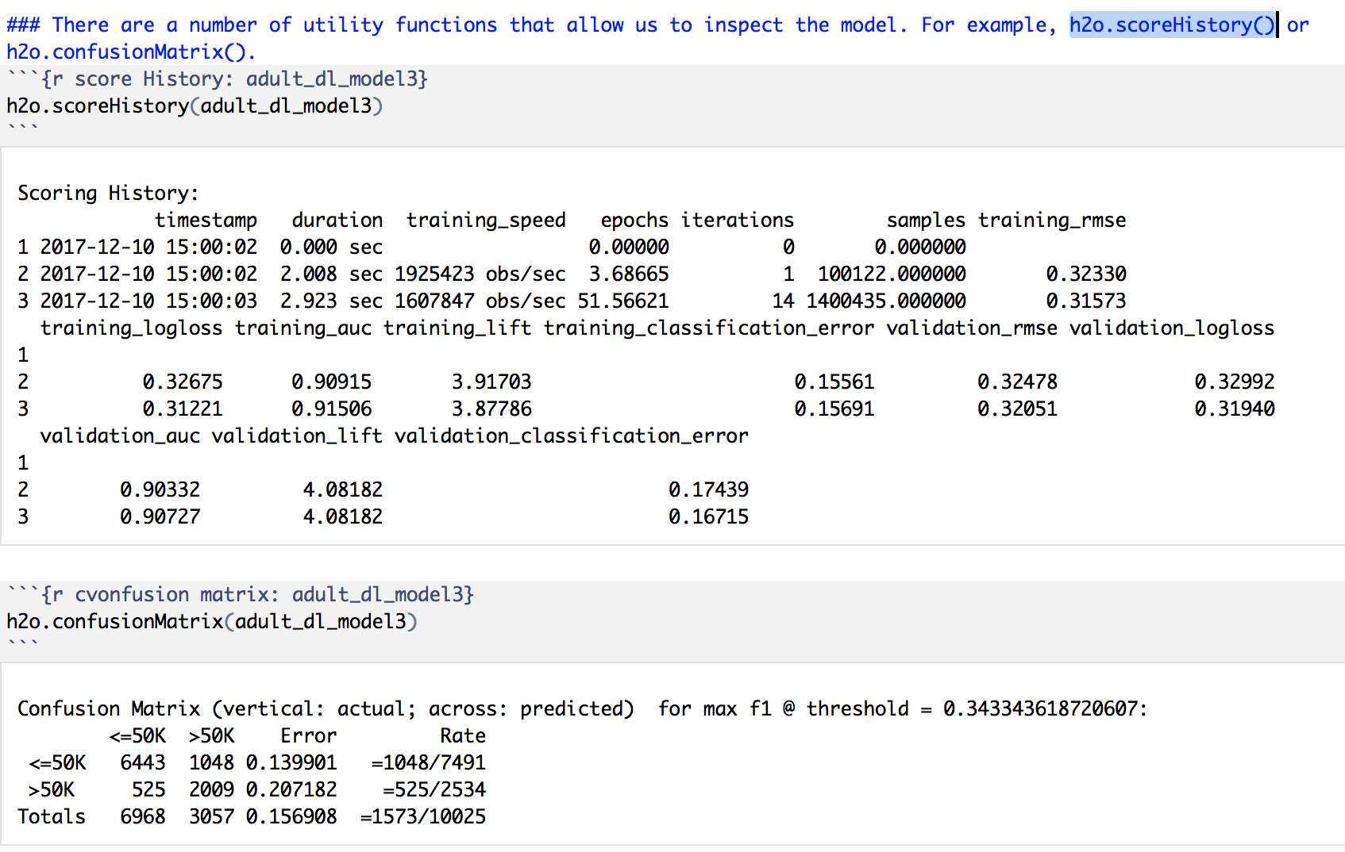

### Plotting Performance of Model 3:

This plot graphs performance in terms of MSE (Mean Squared Error) over the training process.

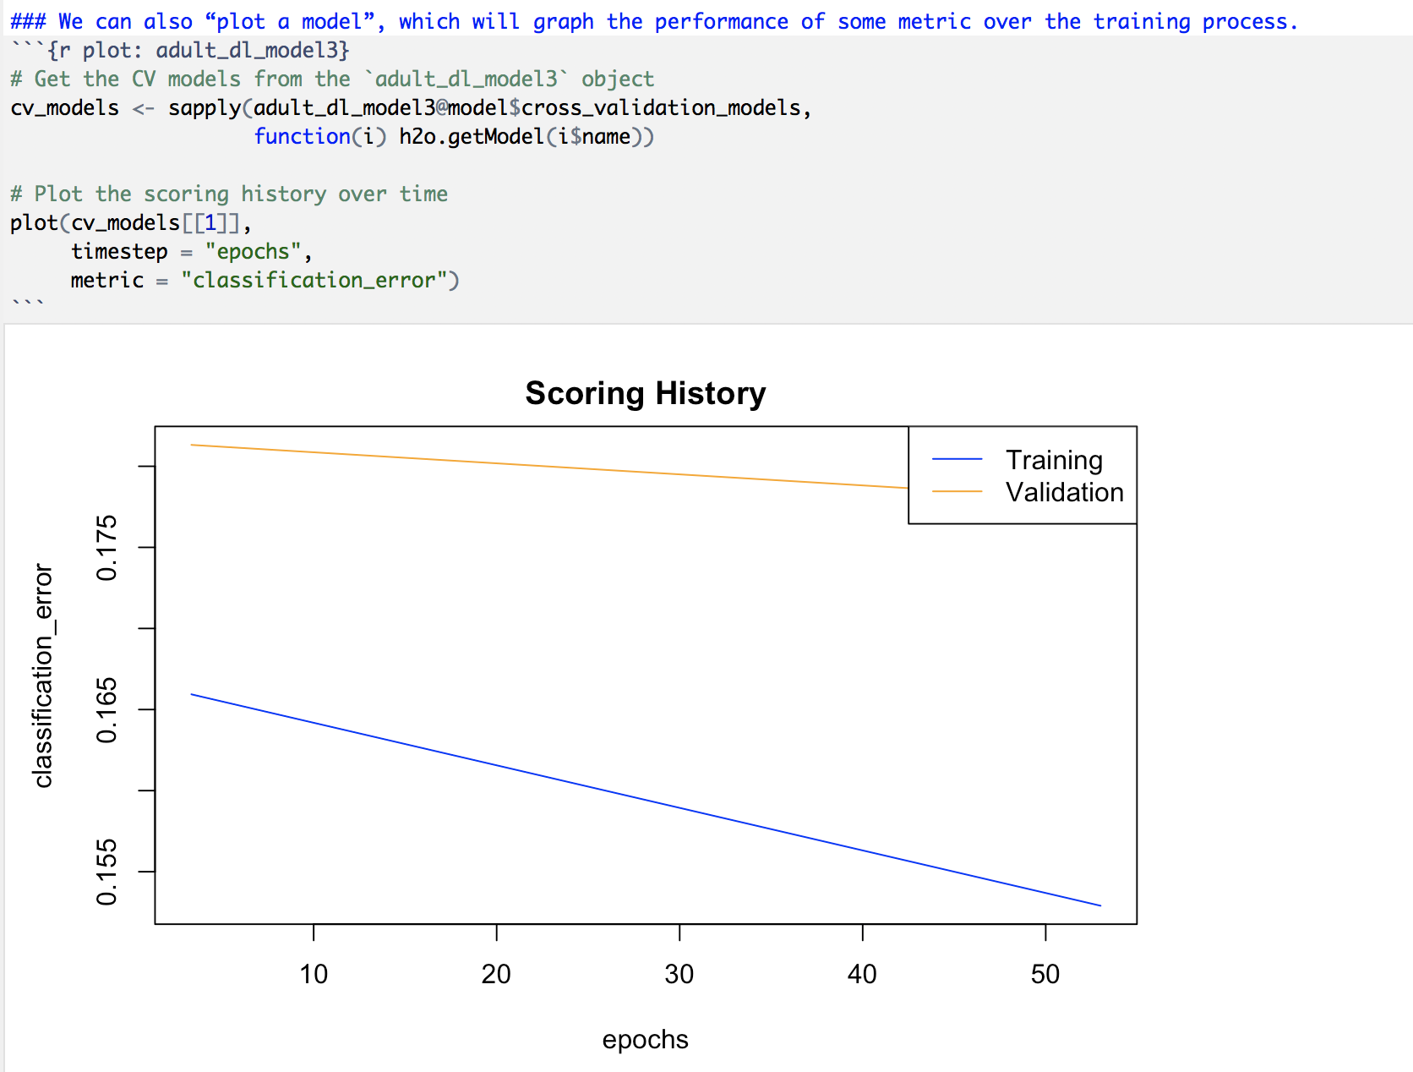

### Deep Learning Grid Search

Random Grid Search is usually a quicker way to find a good model which is an alternative to manual tuning, or “hand tuning”.

1. First define a grid of Deep Learning hyper paramters and specify the search criteria.

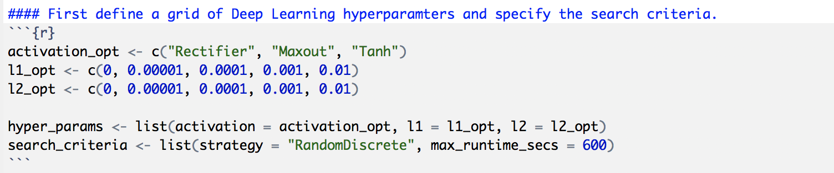

1. Rather than comparing models by using cross-validation (which is “better” but takes longer), we will simply partition our training set into two pieces – one for training and one for validation.

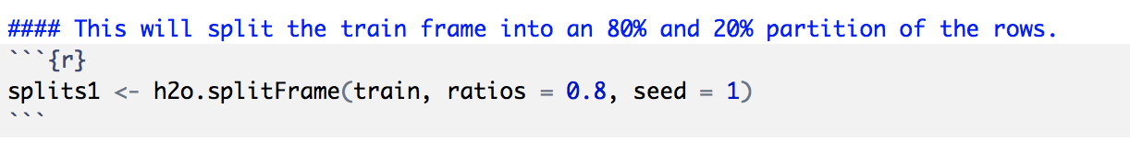

1. Train the random grid. Fixed non-default parameters such as hidden=c(2,2) can be passed directly to the h2o.grid() function.

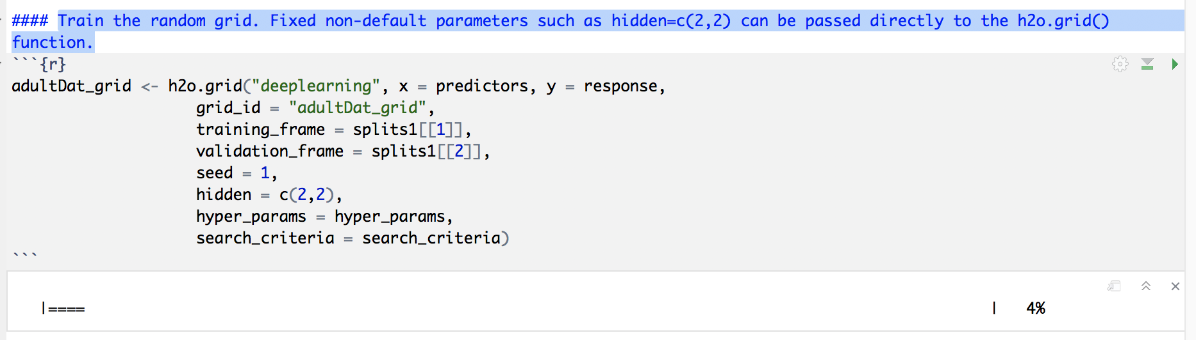

1. Once we have trained the grid, we can collect the results and sort by our model performance metric of choice.

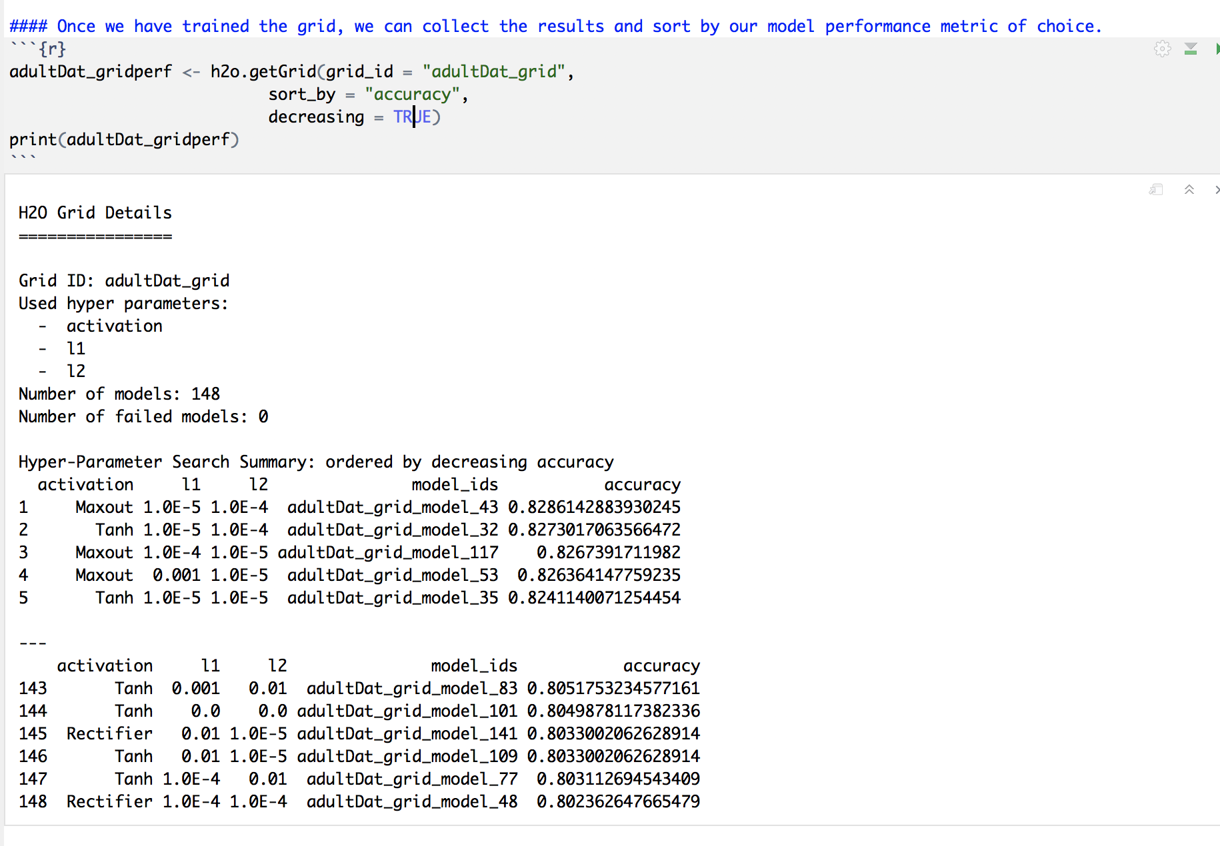

1. Grab the model_id for the top DL model, chosen by validation error.

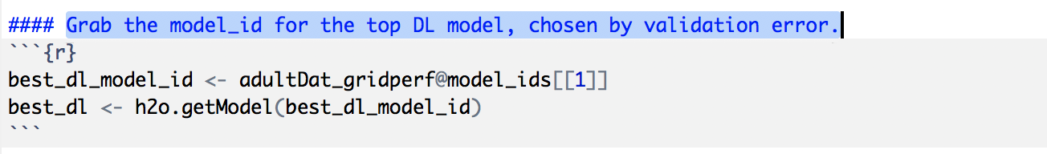

1. Now let’s evaluate the model performance on a test set so we get an honest estimate of top model performance.

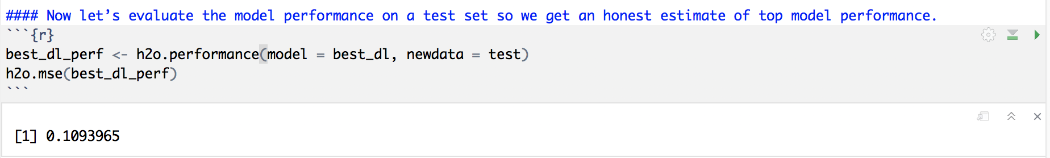

## Summary/ Lessons Learned

Best model has approximately 90% prediction accuracy. In future, I want to learn how to tune parameters better in order to achieve higher accuracy.

In future, I will apply Sparling Water’s all of machine learning algorithms to a bigger data and compare the performance against methods. Also, I will perform dimensionality reduction algorithms and variable reductions based on importance prior to applying deep learning.

This is my first class in the field of big data and it provided the platform to learn and practice advanced topics.

## You Tube Links:

1. 2 minutes presentation: <https://youtu.be/S_YDfDG_PXQ>
2. 15 minutes presentation: https://youtu.be/5ee7IYn-6x4

## References:

1. <http://docs.h2o.ai/h2o/latest-stable/h2o-docs/data-science/deep-learning.html>
2. <https://archive.ics.uci.edu/ml/datasets/Adult>
3. <https://htmlpreview.github.io/?https://github.com/ledell/sldm4-h2o/blob/master/sldm4-deeplearning-h2o.html>
4. <https://spark.rstudio.com/guides/h2o/>
5. <http://docs.h2o.ai/h2o/latest-stable/h2o-docs/welcome.html>
6. <https://databricks.com/spark/about>
7. <http://h2o-release.s3.amazonaws.com/h2o/master/3888/docs-website/h2o-docs/faq/sparkling-water.html>
8. <https://github.com/h2oai/rsparkling>
9. <http://docs.h2o.ai/h2o/latest-stable/h2o-docs/welcome.html>